Updated April 2018
GREENBANK SURGERY
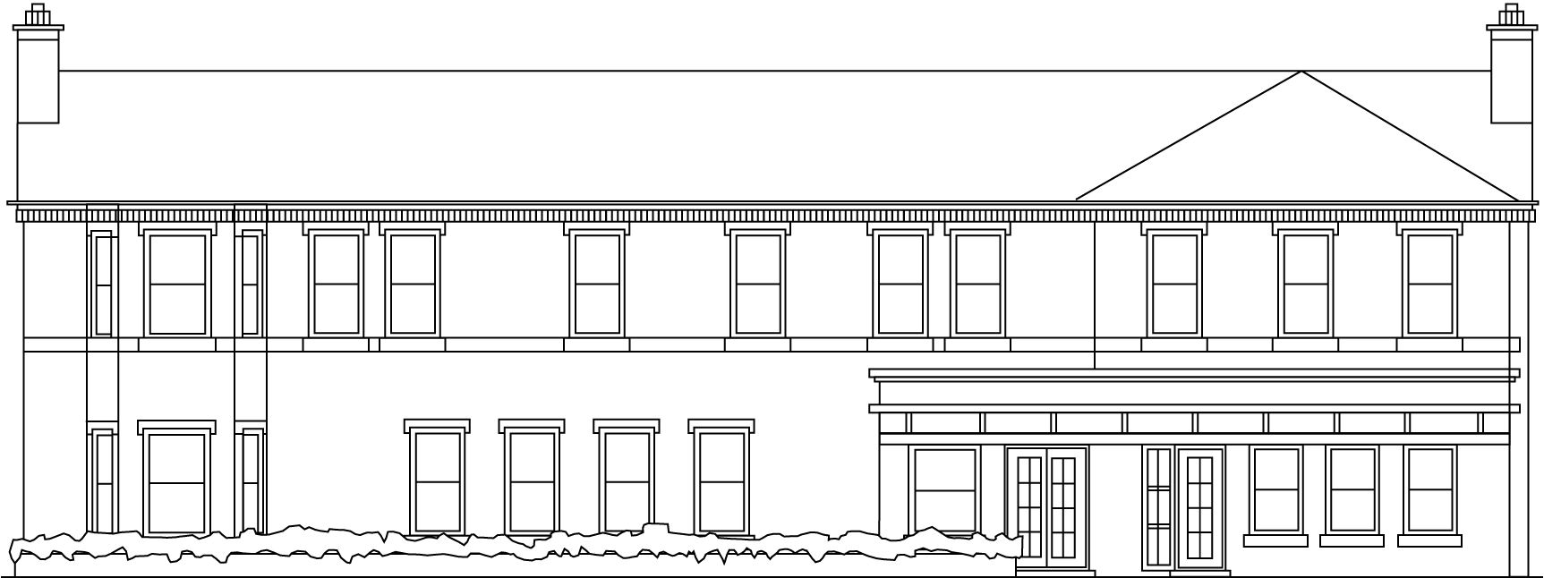

Statement of Purpose
Introduction:

Greenbank Surgery has been established in Warrington for approximately 60 years. In May 2001 our new purpose built surgery was complete and we have been situated here on Manchester Road. Our patients live in all areas of Warrington and we have 8900 people registered with us.

Our Mission Statement:

To deliver to our patients the medical care they deserve, incorporating respect, dignity, confidentiality and joint decision-making.

Our aims and objectives:

As a primary care service provider, our aims are to offer our patients an excellent standard of clinical and personal care, delivered in a caring manner by fully qualified and suitably experienced clinicians; within an appropriate and comfortable environment.

Our values:

We are extremely proud of our heritage as part of the NHS and our values include:

Excellence in clinical quality, customer service and cleanliness of our surgery.
Experience in quality healthcare, trustworthy, safe and dependable.
Integrity in everything we do; we believe in being honest and open.
Accessible to all patients.
Aspiring - our surgery is innovative, dynamic, vibrant and forward thinking.

Quality:

Greenbank Surgery is committed to providing excellent standards of care. All our Health Professionals share this aim, with increasing focus being placed on measurements of clinical outcome and the use of clinical performance indicators and clinical audits. The Surgery also has staff members who are responsible for monitoring service quality and implementing improvements.

Infection control is a vital part of the clinical management of any surgery and at Greenbank we have a robust infection control policy at the centre of our clinical activities.

Health & Safety is taken very seriously and regular risk assessments and other essential checks are carried out at appropriate timescales. These checks include the upkeep and calibration of clinical equipment and the general maintenance of the premises.

Our professional standards at Greenbank Surgery are monitored rigorously through external audits. All errors are logged as "significant events" and documented accordingly. These are available for inspection by authorized authorities.

Services:

Greenbank Surgery in conjunction with secondary care providers, offers a wide range of tests for the diagnosis of medical conditions and treatments and surgical procedures to help patients regain health once a diagnosis has been made. We offer an “open surgery” four mornings per week so patients can come along and sit and wait for a clinician without an appointment. We also offer a daily triage service with a clinician to ensure all patients can have a telephone consultation the same day. If clinically necessary, an appointment with a doctor or other appropriate clinician will be offered. We also offer:

GP Appointments, including Extended Opening on Wednesday Evenings
Extended Access GP Appointments via Bath Street Clinic
Referral to other services
Home visits for housebound patients
Telephone triage/advice
Repeat prescriptions, including Electronic Prescribing
Provide details of how to access Out of House Services
Results of tests

The following clinics are available in this surgery:

Antenatal
Nurse-led clinics for smears & family planning
Child Health Surveillance
ECG Tests
Minor Surgery
Dementia Reviews
Travel
Chronic Disease Management: (Hypertension, Diabetic/IGT/IFG, Heart disease, COPD, Asthma, Chronic Kidney Disease).
Citizens Advice Bureau
NHS Health Checks
Twenty Four Hour Blood Pressure Checks
Ear Syringing
Immunisation

Patients can book GP appointments at any time during the day or night, including weekends and Bank Holidays, via our 24 hour on-line booking system. We have a self "check-in" for patients attending for appointments and a computerized "patient calling" system, facilitating both audio and visual, for patients convenience.

Patients can view their Summary Care Record, order Prescriptions and view coded medical information on-line, providing they have supplied relevant and correct documentation.

Patient Forum:

The Patient Forum was established in 2004, all registered patients at this surgery are welcome to join our Forum and we continue to try and recruit more members. We actively support the Forum and work alongside Warrington CCG in doing so.

Listening to your views:

We also value the opinions of our patients and seek to gain feedback in a number of ways, such as patient questionnaires which we encourage patients to complete from time to time.

Greenbank Surgery also commissions surveys of patient satisfaction that is carried out by an independent third party or via our website. The results of the last main survey carried out are available on the website, patient forum notice board and at the surgery receptions desk.

The National GP Survey results are available on our website and a copy is on display in the surgery for patients to view.

A dedicated "suggestions box" is situated within the reception area. We welcome feed-back for the “Friends & Family” test.

All complaints are dealt with in a confidential manner and are fully investigated.
Complaints will, usually, be acknowledged within 3 working days, with a written reply within 10 working days, if we are not able to respond fully there and then. If a complaint is serious and takes longer to resolve, we will regularly update you on progress.

Whilst we always strive to resolve complaints quickly and locally. In the unlikely event that we are unable to resolve your complaint, you will be advised, if appropriate, on how to take the matter forward. Complaints can be sent to:

The Parliamentary and Health Service Ombudsman
Millbank Tower
Millbank
London
SW1P 4QP
Tel: 0345 0154033
Website: www.ombudsman.org.uk

The Surgery:

Greenbank Surgery does not discriminate. All personnel will have due regard to patients' gender, religion and spiritual needs, age, sexuality, racial origin, and cultural and linguistic background and any disability.

During every visit to Greenbank Surgery patients can expect respect, privacy, dignity, equality, independence and choice.

The surgery has disabled facilities.

We are able to offer a wheelchair or hearing loop facilities to patients attending at the surgery.

We are registered as a “safe place” for vulnerable people.

The practice will involve the patients in their own care as much as practicable through a process of self-care and education, geared to individual needs, and will encourage them and their families or carers to become involved in decisions relating to care delivery.

The practice will offer choice to patients consistent with local and national resources, and will offer sufficient information to enable a balanced decision to be made.

Patients will be offered information about the surgery's services in a style which is not misleading and does not make inaccurate claims.

Patients will be given a clear explanation, from their clinician, about their condition, treatment, investigation or proposed procedure, including any risks and alternatives, before agreeing on the course of action.

Patients will be able to seek a second opinion, if they wish to do so.

Patients will have access to their medical records in accordance with the Data Protection Act 1998.

Patients can discuss health related matters with health care professionals of the same sex, where possible.

Patients can request a trained clinical chaperone if they are undergoing an intimate examination.

Nursing mothers will be offered a private room if requested.

Assistance dogs are welcome to attend with patients.

Patients who wish to speak in private to anyone, can be provided with a separate room.

We strive hard to achieve our Quality and Outcome Framework targets.

We participate in the vast majority of Enhanced Services offered to us by NHS England and Public Health England. We also participate in local Enhanced Services offered by Warrington Clinical Commissioning Group (CCG). We work closely with and support Warrington CCG in many areas including Medicines Management.

We are an accredited training practice; we help to train Registrars, F2’s and medical students.

We are part of the Phoenix Federation and Warrington East Cluster groups.

We support the Carers Association and have a dedicated “Carers Notice Board” in reception

Confidentiality:

All of our staff - clinical and administrative, have access to patients medical records, to allow them to perform their duties in a safe and proper manner. All staff members are bound by strict rules of confidentiality and the Data Protection Act 1998. We adhere to strict rules of Information Governance as laid down by the Department of Health.

The Surgery Team:

The Partners:

Dr M Northey – Senior Partner, Dr R Owens, Dr K Cox and Mrs Emma Scott, Advanced Nurse Practitioner

Practice Manager:

Mrs Gwen Green

Office Manager:

Mrs Joanne Gerrard

Salaried GPs:

Dr I Andrew-Okunzuwa
Dr Y Hameed
Dr R Pollitt

The Practice Nurse Team:

Tracey Bowen
Carol Ratcliffe
Angela Dewhurst
Jayne Lawson – Healthcare Assistant

Greenbank Surgery has a large team of receptionists and administrators dedicated to your well-being, supporting the clinicians and management. All of our staff members have qualifications relevant to their roles and we actively support and encourage their continuing education and development. All staff including clinical and administrative have undertaken a Disclosure & Barring Service check.

Regulation:

As from April 2013, Greenbank Surgery is regulated by the Care Quality Commission. If any change takes place relating to the surgery, for example, a change in partnership, the surgery is obliged to inform this regulator.

The Care Quality Commission (CQC) can be contacted for general queries at:

Care Quality Commission,
St Nicholas Building
St Nicholas Street
Newcastle-Upon-Tyne
NE1 1NB
Telephone: 03000616161

A copy of the CQC's most recent inspection report will be available on request from the CQC (www.cqc.org.uk)'s office, or from the Surgery.

The registered GP Partner of Greenbank Surgery is Dr Michael Northey. He can be contacted in writing at Greenbank Surgery, 274 Manchester Road, Warrington WA1 3RB or by telephone on 01925 631132.

